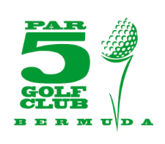
ENTRY FORM

TEAM: $560 includes green fees, cart and lunch (at Bella Vista)
Date: Sunday, October 6th 2019 – Port Royal – 8am Shotgun - Captains Choice

Forms may be handed to any PAR 5 Executive Member or call 777-7729 or 705-9022 or email PAR5bda@gmail.com to register your team.
Please register early to avoid disappointment.

Proceeds to benefit the Bermuda Wonens’ Under 17 National Football Team.

Payment and/or donations may be made to PAR5 Account
Butterfield Bank - 0601-592940-011

PAR 5 FALLEN HEROES BENEFIT GOLF TOURNAMENT
@ PORT ROYAL GOLF COURSE
8am Shotgun
Captain’s Choice

Team Name/Captain _____________________________________

Phone #:_______________________________________________

Email_________________________________________________

Player 1_______________________________________________

Player 2_______________________________________________

Player 3_______________________________________________

Player 4_______________________________________________

NB Tee/Green advertisements available – $200 per placement

